- What are the top 10 occupations for H1B visas with certified status?

  - SOFTWARE DEVELOPERS, APPLICATIONS: 16,126
  - COMPUTER SYSTEMS ANALYSTS: 12,487
  - COMPUTER PROGRAMMERS: 9,965
  - COMPUTER OCCUPATIONS, ALL OTHER: 6,328
  - COMPUTER SYSTEMS ANALYST: 3,385
  - SOFTWARE DEVELOPERS, SYSTEMS SOFTWARE: 2,528
  - MANAGEMENT ANALYSTS: 1,674
  - ACCOUNTANTS AND AUDITORS: 1,575
  - NETWORK AND COMPUTER SYSTEMS ADMINISTRATORS: 1,166
  - COMPUTER AND INFORMATION SYSTEMS MANAGERS: 1,060
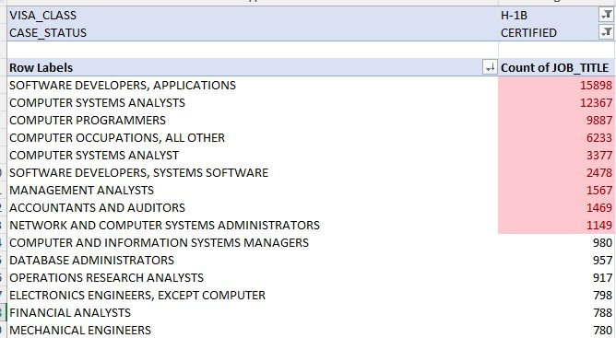

- Which company hires more data scientists?

Microsoft Corporation has haired most data Scientists.

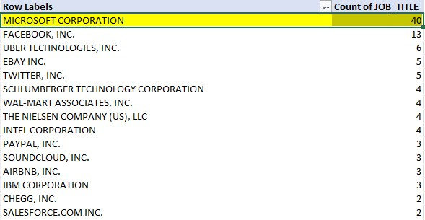

- What is the average salary for data scientists?

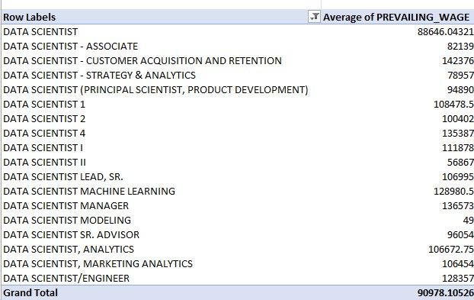

- Which state has the higher deny proportionally to application?

  - AS has a highest proportion of denial rate of 100%.

- What industries are in the top 5 percentile of applications?

Row Labels | Count of CASE_NUMBER
Custom Computer Programming Services | 31941
Computer Systems Design and Related Services | 6742
Computer Systems Design Services | 5311
Colleges, Universities, and Professional Schools | 5100
Management, Scientific, and Technical Consulting Services | 3689

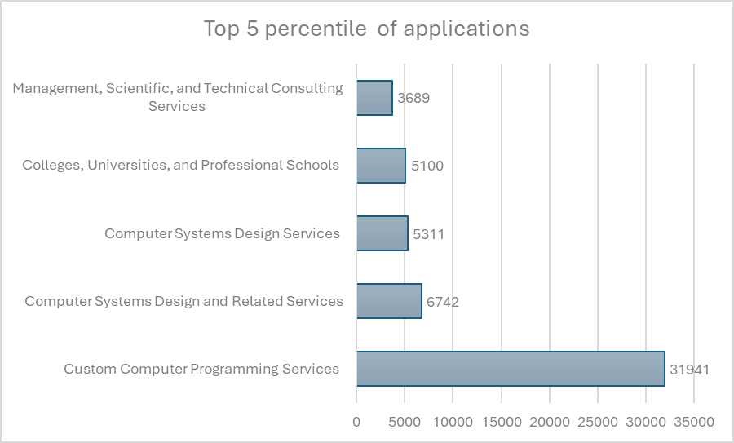
- Does the month of the application play any role in to denied process? What about decision dates?

Highest Denial rates (decision)
- December: 33.97%
- November: 33.60%
- October:32.43%

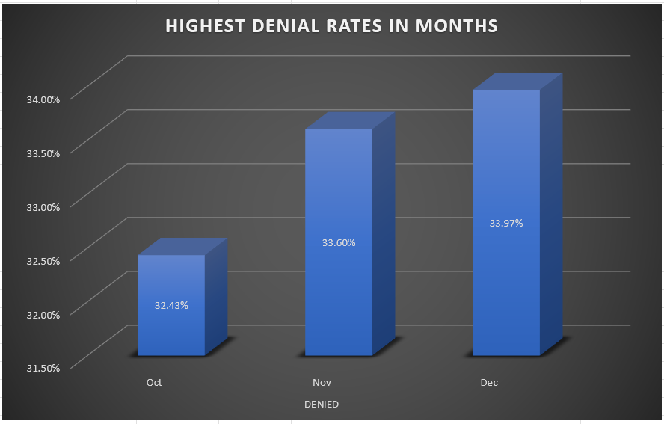

Highest denial rates (applications submitted in:)
